**Assignments: Core 3 Spike report**

## **Dilni De Silva 103616345**

### Repository:

<https://github.com/Dilni-DS113/D311_Dilni_CORE_03>

### Goal:

This application here uses recycle views to take data from a file and implement it to the recycle view as well saving data using shared preferences.

### Resources:

Skill gap 2 → Toasts and Snack bars

<https://developer.android.com/guide/topics/ui/notifiers/toasts>

Skills gap 4 → Follow the documentation to implement a new concept

<https://www.tutorialkart.com/kotlin-android/android-textview-text-color/#:~:text=Android%20TextView%20%E2%80%93%20Text%20Color,file%20using%20setTextColor()%20method>.

### Skills gaps and solutions:

1. Command of IDE

IDE build displays the application as running on a mobile phone, where a developer can view and test the application's functionality.

Solution:

* Be able to select a device from the device manager and run the machine.
* Be able to view the device on the emulator tab.
* Be able to power up the emulator.
* Be able to press the green arrow button to run the application.
* Be able to use and view applications on the emulator.

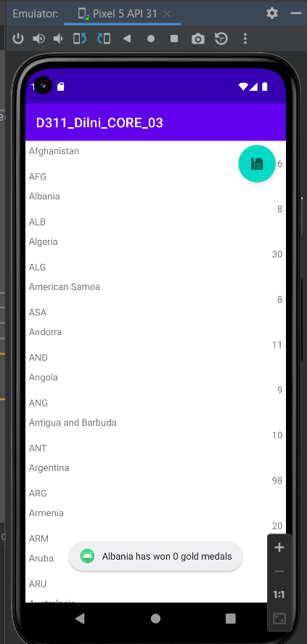

1. List performance and adapters

Using a recycle view data from a CSV file is outputted to that recycle view so that data can be displayed in rows depending on the line the data was presented in the CSV file.



* Be able to create an adapter class and create the following methods
  + Be able to create getIteamCount
  + Be able to create onBindViewHolder
  + Be able to create Inner class ViewHolder
* Be able to create a data class to store data from file
* Be able to create an object to store data from files into a mutable list
* Be able to initialise files in the main activity
* Be able to create a list in the main activity
* Be able to add items from the file into a list
* Be able to bind the list and the file data by using an adapter

1. Toasts and Snack bars

Toast is used to display a feedback message to users about an action that was taken. In this context, it would be a message displaying data from the last clicked list.



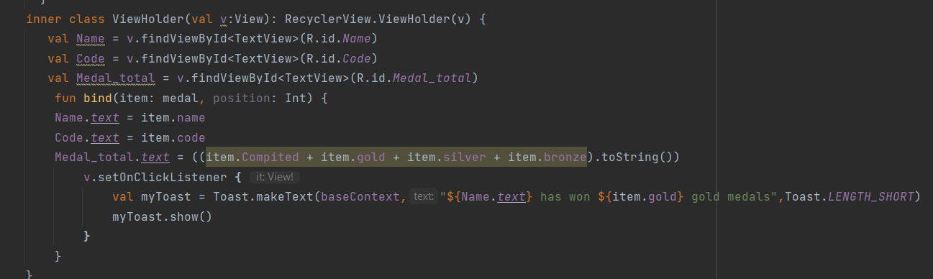

* Be able to add a click listener in the bind method in the adapter.
* Be able to read toast documentation.
* Be able to create a toast variable.
* Be able to call a text message for a Toast statement adding the context of the adapter and certain data from the file.
* Be able to display toast using the show() method.

1. Follow the documentation to implement a new concept

The documentation concept added was to implement changing the colour of the text data sent to the detailed activity.

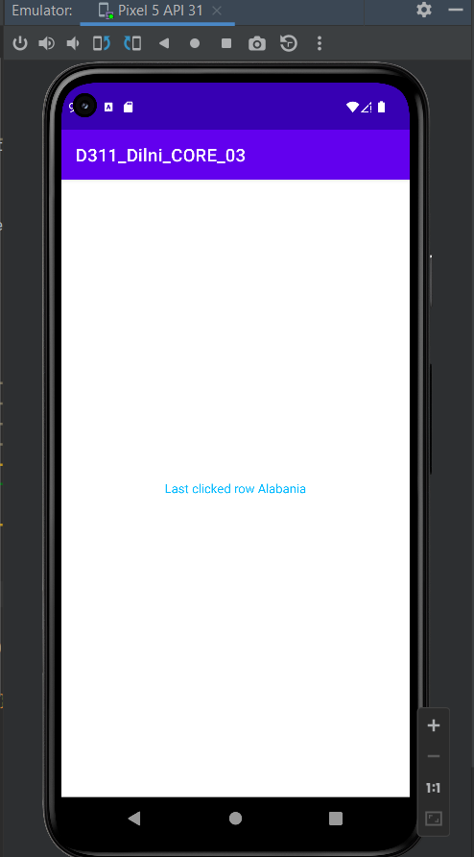

* Be able to research colour-changing documentation
* Be able to look up HTML code for colour
* Add a set colour method to the text view
* Add colour HTML to the set colour statement colour

1. Understand the filesystem

Instead of using a saved state using shared principals data can be saved and transported to another file in the application resources.

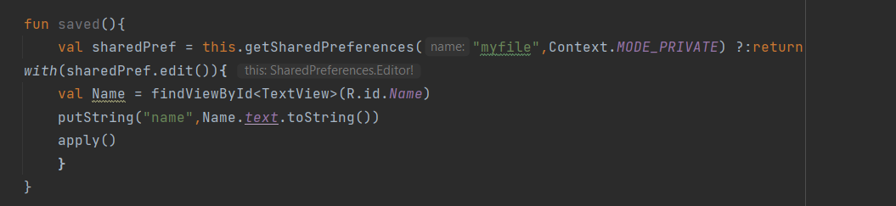

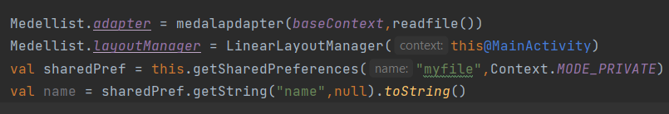

* Be able to create a saved function
* Be able to create shared preferences for the text view from the layout row activity.
* Be able to create a link to the data from the recycle view and shared preference.